DBMS Assignment 5
(Exercise on retrieving records from the table)
EMPLOYEES (Employee_Id, First_Name, Last_Name, Email, Phone_Number, Hire_Date, Job_Id, Salary, Commission_Act, Manager_Id, Department_Id)
( a) Find out the employee id, names, salaries of all the employees
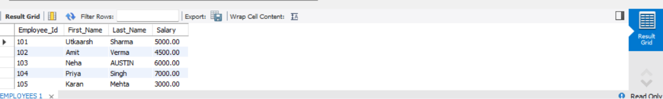

( b) List out the employees who works under manager 100
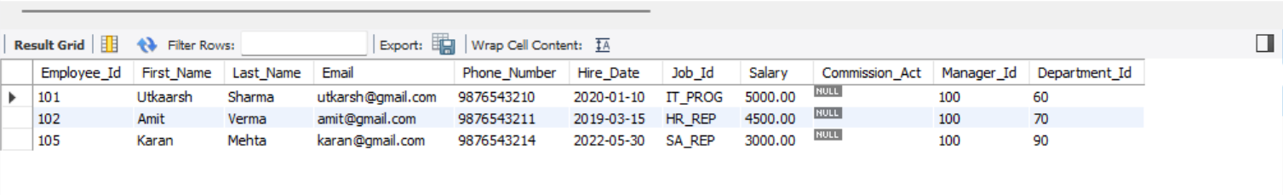

( c) Find the names of the employees who have a salary greater than or equal to 4800
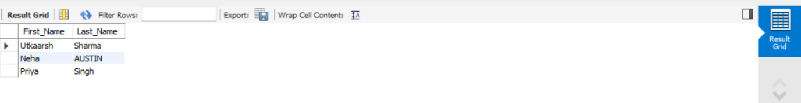

( d) List out the employees whose last name is ‘AUSTIN’
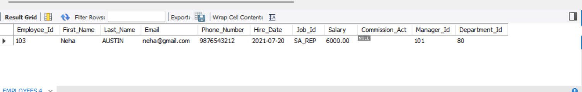

( e) Find the names of the employees who works in departments 60,70 and 80 ( f ) Display the unique Manager_Id.
